PROGRAM
INTERNATIONAL CONFERENCE
Air-Land-Sea Interactions ICALSI 2019

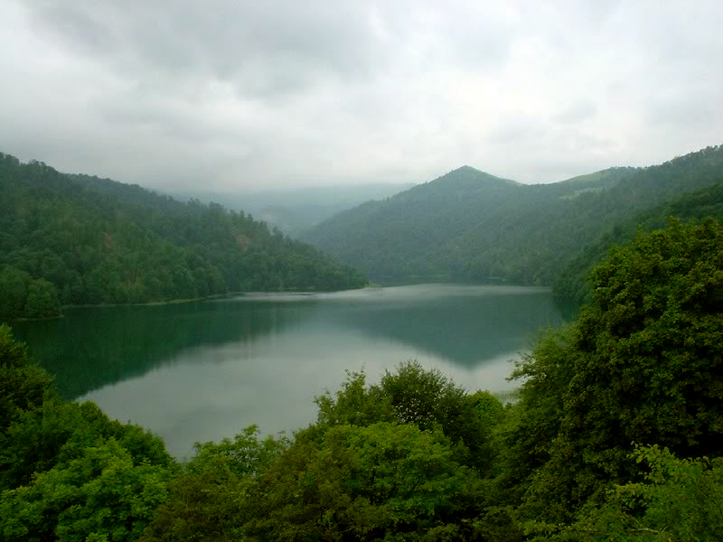

4-5 April 2019
Baku, Azerbaijan

HONORARY BOARD________________________________

- Hamlet ISAXANLI - Founder, Khazar University, Baku, Azerbaijan
- Mehmet KARACA - Rector, Istanbul Technical University, Istanbul, Turkey
- Mustafa AYDIN - President, Istanbul Aydın University, Istanbul, Turkey
- Yadigar IZMIRLI - Rector, Istanbul Aydın University, Istanbul, Turkey
- Jiang ZHU - Director, Institute of Atmospheric Physics, Chinese Academy of Sciences, Beijing, China

CHAIRS________________________________________

Chair:
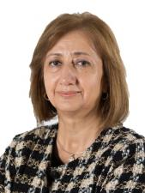
Zafer ASLAN, Istanbul Aydın University, Istanbul, Turkey

Co-chairs:

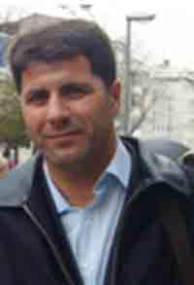

Rovshan Abbasov, Khazar University
Baku, Azerbaijan

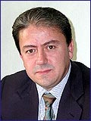

Orhan Şen, Istanbul Technical University
Istanbul, Turkey

ORGANIZING COMMITTEE_________________________

Irada KHALILOVA - Khazar University, Baku, Azerbaijan
Zafer ASLAN - Istanbul Aydın University, Istanbul, Turkey
Rovshan ABBASOV – Khazar University
Hasan HEPERKAN - Istanbul Aydın University, Istanbul, Turkey
Donald GABRIELS - UNESCO Chair on Eremology, Ghent University, Belgium
Orhan ŞEN - Istanbul Technical University, Istanbul, Turkey
Ahmet Duran ŞAHİN - Istanbul Technical University, Istanbul, Turkey
Ceyhan KAHYA - Istanbul Technical University, Istanbul, Turkey
Lamiya PANAHOVA – Khazar University, Baku, Azerbaijan
Aygun ALIYEVA – Khazar University, Baku, Azerbaijan
Gunay KARIMOVA – Khazar University, Baku, Azerbaijan

SCIENTIFIC COMMITTEE__________________________
Rza MAHMUDOV - Ministry of Ecology and Natural Resources of Azerbaijan Republic
Elshan ABDULLAYEV - Institute of Geography, AMEA, Baku, Azerbaijan
Rovshan ABBASOV - Khazar University, Baku, Azerbaijan
Zelha ALTINKAYA - Yalova University, Yalova, Turkey
Zafer ASLAN - Istanbul Aydın University, Istanbul, Turkey
Duncan AXISA - NCAR, Boulder, USA
Robert BORNSTEIN - San Jose State University, USA
Zafer BOYBEYİ - George Mason University, USA
Roelof BRUINTJES - NCAR, Boulder, USA
Ivana Herceg BULIC - University of Zagreb, Croatia
Don COLLINS - Texas A&M University, USA
Deniz O. DEMİRCİ - Boğaziçi University, Istanbul, Turkey
Funda DÖKMEN - Kocaeli University, Izmit, Turkey
Gokhan ERDEMİR - Istanbul Zaim University, Istanbul, Turkey
Gunay Erpul - Ankara University, Turkey
Donald GABRIELS - UNESCO Chair on Eremology, Ghent University, Belgium
Ali GÜNEŞ - Istanbul Aydın University, Istanbul, Turkey
Mikdat KADIOGLU - Istanbul Technical University, Turkey
Ceyhan KAHYA - Istanbul Technical University, Turkey
Doğan KANTARCI - Istanbul University, Turkey
Kasım KOÇAK - Istanbul Technical University, Istanbul, Turkey
Deyanira LOBO - Central University of Venezuela
Sibel MENTEŞ - Istanbul Technical University, Turkey
Mehmet Talad ODMAN - Georgia Institute of Technology, USA
Gürcan ORALTAY - Marmara University, Turkey
Güven ÖZDEMİR - Istanbul Technical University, Istanbul, Turkey
Hasan Sabri ÖZTÜRK - Ankara University, Turkey
Ahmet Duran ŞAHİN - Istanbul Technical University, Istanbul, Turkey
Orhan ŞEN - Istanbul Technical University, Istanbul, Turkey
Ömer Lütfi ŞEN - Istanbul Technical University, Turkey
Elçin TAN - Istanbul Technical University, Turkey
Hasan TATLI - Çanakkale Onsekiz Mart University, Turkey
Ali TOKAY - University of Maryland-Baltimore, USA
Ahmet TOKGÖZLÜ - Süleyman Demirel University, Isparta, Turkey
Doğanay TOLUNAY - Istanbul University, Turkey
Sema TOPÇU - Istanbul Technical University, Turkey
Hüseyin TOROS - Istanbul Technical University, Turkey
Osman UÇAN - Altınbaş University, Istanbul, Turkey
Lin WANG - Chinese Academy of Sciences, Beijing,China
Yalçın YÜKSEL - Yıldız Technical University, Istanbul, Turkey

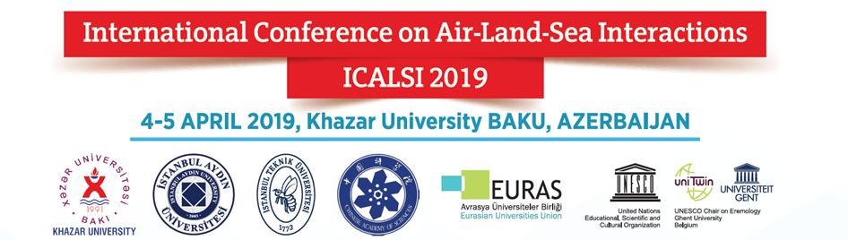

Marble Hall, Khazar University

09.15 – 09.45  09:45 – 10.20 | 4 April 2019  REGISTRATION  OPENING SESSION & WELCOME SPEECH  Rovshan Abbasov, PhD  Conference Chair, Head of Department of Geography and Environment, Khazar University, Azerbaijan  Prof. Hamlet Isakhanli  Founder of Khazar University, Azerbaijan  Zafer Aslan, PhD  Vice-Rector, Istanbul Aydin University, Turkey
10:20 – 11:00  11:00 – 11:15 | Ahmet D. SAHIN, Istanbul Technical University  Solar Energy systems, on Sea Surface, Case in Istanbul  COFFEE BREAK
11.45 – 11:30  11:30 – 11:45  11:45 – 12:00  12:00 – 12:15  12:15 – 12:30  12:30 – 12:45  12:45 – 13:00 | Session I  Chairperson: Rovshan Abbasov  Mahluga Yusifova, Nigar Sultanova  Prospects of the consumption of biofuels in Azerbaijan  Rza Mahmudov  The influence of contemporary clımate changes to hydrometeorological securıty of Traceca region  Rovshan Abbasov  Developing Environmentally Sustainable scenariopus for the future development and use of Khojasan lake, Azerbaijan  Elnur Safarov  The Caspian Sea level variations on the background of the global climate impacts  Gulnar Abdullayeva, S. M. Rüstəmova, I. M. Hüseynova  Sequence analysis of dreb gene from wheat genotype 'Barakatli 95'  Vaqif Farzaliyev, Gunay Ismailova, Bella Musayeva, Nelya Novotorjina  Study of sulfur, nitrogen-organic compounds obtained from ecologically pure glycerol derivatives  Evaluation of Session I
13.00 – 14.00 | Lunch
14:00 – 14:15  14:45 – 14:30  14:30 – 14:45  14:45 – 15:00  15:00 – 15:15  15:15 – 15:30  15:30– 15:45 | Session II  Chairperson: Ahmet D. SAHIN  Aysel Mammadova  Environmental impacts from natural resources in Azerbaijan  Ulduza Gurbanova, Shahniyar Bayramov, Irada Huseynova  Dynamics of some carbon and nitrogen metabolism enzymes during the day in various wheat genotypes under drought  Nargiz Sultanova  Occurrence and diversity of single and double viral infections of solanaceous crops in Azerbaijan  Alibaba Niftaliev, Imran Amirov, Albert Tagiev  Assessment of environmental pollution along the coastlines of the Caspian Sea  Ruhangiz Mammadova, Leyla Nagiyeva  Identification verticillium dahliae resistant cotton genotypes using chromosome substitution lines  Evaluation of Session II  COFFEE BREAK
15:45 – 16:00  16:00– 16:15  16:15 – 16:30  16:30– 16:40  16:40 – 16:50  16:50 – 17:00  17:00-17.10 | Session III  Chairperson: Zafer ASLAN  Rovshan Karimov  Road transport and air pollution in Azerbaijan  Lale Aydinli, Durna Aliyeva  Diurnal temperature-related dynamics of glutathione reductase activity in wheat genotypes under drought  Rustam Rustamov  Conceptual approach of the regional problem of the global climate change  Nemat Hasanov  Environmental problems of the Caspian Sea  Matanat Avazova  Land Degradation in Azerbaijan  Keramova Ramida Aga-Dadash  Microseismic zones of the Caspian sea, first identified on the basis of the abnormalities in the year-round monitoring of the underground water’s regime in Azerbaijan (1986-2014)  Evaluation of Session III
17:10– 17:25  17:25 – 17:40  17:40 – 17:55  17:55 – 18:05  18.05 – 18:15  18:15-19.00 | Session IV  Chairpersons: Rovshan ABBASOV /  T. Y. Isgandarova, S. M. Rustamova  Catalase activity during flag leaf senescence of wheat plants under water deficit  Zelha Altınkaya  Awareness of university students on renewable energy  Jevahir Rajabli, Gulgez Nagiyeva  Environmental problems of cleaning water and ground surfacefrom petroleum and petroleum products  Maksud Babaev, Gunay Hasanova  The Role of the Kur River Basin in the economy of Azerbaijan  Evaluation of Session IV  PROJECT WORKSHOP (with invitation)
09:15 – 09:40  09:40 – 10:00  10:00 – 10:20  10:20 – 10:30  10:30-10.45 | 5 APRIL 2019  Orhan SEN, Istanbul Technical University  Carbon Emissions, market and trading  Donald GABRIELS, UNESCO  Land Degradation and Desertification: An Interaction of Land, Water and Weather  S. T. Zulfugarova, S. A. Omarova, S. M. Rustamova  Study of membrane stability and membrane damage rate in wheat cultivars under heat stress  Gulnara Shikhseyidova, Samira Salayeva, Ellada Akhundova  Biodiversity assessment of durum wheat accession based on molecular markers  COFFEE BREAK
10:45 – 11:00  11:00 – 11:15  11:25 – 11:30  11:30 – 11:45  11:45 – 12:00  12:00 – 12:15  12:15-12: 30  12:30-12.45 | Session V  Chairpersons: Donald GABRIELS /  Gulnara Guluzada, Javid Ojaghi  Assessment of synthetic hexaploid wheat based on biomorphological traits in salt stress condition  Pervin Mamedova, Konul Kakhamanova, Elbei Babayev, Tarana Ibraqimova  Microbiological purification of oil pollution in Caspian sea waters  Vaqif Farzaliyev, Gunay Ismailova, Bella Musayeva, Nelya Novotorjina  Study of sulfur, nitrogen-organic compounds obtained from ecologically pure glycerol derivatives  Zehra Betül Öcal Sarıhan, Ahmet Karagündüz  Developing a sustainable process with boron removal from water  Orhan Şen, Merve Yılmaz, Esra Kesef, Evren Özgür  Air pollution and inversion features in Erzurum, Turkey  Zeynep F. Ünal, Onur Uysal, Elçin Tan, Orhan Sen  Meteorological analysis of winter sports in various places in Turkey  Zeynep F. Ünal, Umur Dinc, Hüseyin Toros  Application of Deep Learning Method for Air Pollution Forecasting on Ankara  Evaluation of Session V
12.45-13.00 | Closing Remarks  Zafer Aslan  İstanbul Aydın University  Rovshan Abbasov  Khazar University  Shlomo Weber  Professor Emeritus, Southern Methodist University, Dallas, USA  Donald Gabriel  UNESCO Chair on Eremology, Ghent University, Belgium
13.00 – 14.00 | Lunch
14.00 | Day trip starts
POSTERS

Fatma Suleymanova
Change of microfaunist residues based on mineralogical and geochemical analysis (using the example of the Khara-Zira area)
Buket Kılıc, Zafer Aslan
Predictability and feedback effects of land surface classification and atmospheric parameters
Eldar Muradly
Reconstruction of quantitative indicators of azerbaijan's climate in early pleistocene based on mineralogical information
Emrah Tuncay Ozdemir, Omer Yetemen, Zafer Aslan
Investigation of Wind Storms & Heavy Rain at Newcastle Williamtown Airport in Australia
Keramova Ramida Aga-Dadash
Microseismic zones of the Caspian sea, first identified on the basis of the abnormalities in the year-round monitoring of the underground water’s regime in Azerbaijan (1986-2014)
Ramida Keremova, Yusifova Kh. Kh., M. G. Badalova, S. N. Gurbanzadeh
Abnormal changes in the radon field in the groundwater of Azerbaijan in the preparation of strong earthquakes (on the example of local and remote earthquakes)
Rustam Rustamov
Conceptual approach of the regional problem of the global climate change
Gulnur Salmanova
Climate change impacts on water resources of Shaki-Zagatala region, Azerbaijan
Sevinj Burzuyeva
Contemporary changes in high mountain landscapes in southern slopes of Great Caucasus, Azerbaijan
Rashail Ismailov
Transboundary pollution in the Kura river basin

