Azarbaycan Arxcologiyasi 1999
Azerbaijan Archaeology Vol.: 1 Num.: 1-2

ABOUT THE STONEHENGE MONUMENT
Richard Pegge
(England, Azerbaijan International Operating Company)

"Stonehenge: (steiin'hendj) A unique megalithic monument on Salisbury Plain in Wiltshire, England. Its alleged connection with the Druids dates from the 17th c, when people's ideas about what constituted 'the past' were very vague. In the 12th c. it was believed to be a monument over King Arthur's grave; other theories have attributed it to the Phoenicians, Romans, Vikings, and visitors from other worlds; modern theory inclines to the view that it was a temple. Scientific study and excavation have identified three main constructional phases between c.3000 BC and c.1500 BC, i.e. it was completed in the Bronze Age. The circular bank and ditch, double circle of 'bluestones' (spotted dolerite), and circle of sarsen stones (some with white lintels), are concentric, and the main axis is aligned on the midsummer sunrise—an orientation that was probably for ritual rather than scientific purposes." (Copyright — The Oxford Encyclopaedic English Dictionary, Clarendon Press, Oxford (1991))
Built between 3100 and 1550 BC, Stonehenge is by far the most famous prehistoric megalith in Europe. Of all the megalithic monuments in Europe, Stonehenge is unique because of the precision of its architecture and its extended use throughout history.
It lies 13 km (8 mi) north of Salisbury, England. Research, through excavation (by London's Society of Antiquaries, beginning in 1919) and radiocarbon dating, has proven that Stonehenge has an exceptional long history of use as a ceremonial and religious centre.

COMMON BELIEFS

A circular group of massive, upright stones, the Stonehenge monument was once thought to have been a type of prehistoric astronomical observatory or clock for predicting the seasons and other astronomical events.
Stonehenge's axis is pointed roughly in the direction of the sunrise at the summer and winter solstices. Some scientists believe that early peoples were able to foretell eclipses of the sun and the moon by the positions of these celestial bodies in relation to the stone

ft
it

"8* *****

Azarbaycan Arxeologiyasi
1999
monument. The site may have served as an observatory where early rituals or religious ceremonies took place on specific days of the year.
The early belief that the monument was built as a temple for sky worship has never been definitively proven.
Another earlier notion was that Stonehenge was connected with the Druids, a caste of Celtic priests. Druids did not appear in Britain until a few hundred years before the Christian era; so the belief that Stonehenge was a Druid temple seems to hold no weight with science.
Four periods of building, according to evidence unearthed in the excavations, seem to have existed in connection with the Henge.

50
Azerbaijan Archaeology Vol.: 1 Num.: 1-2
PERIOD I (c. 3100 - 2300 BC) -Neolithic Age

The site was enclosed by a circular ditch with an internal bank and northeastern entrance. On the inside of the ditch were a ring of 56 pits (named Aubrey holes for their 17th-century discoverer, John Aubrey—that later were used for the burial of cremated bodies). On the outside of the entrance, the builders erected the huge, upright Heelstone and a timber gate.

PERIOD II (c.2100 - 2000 BC)

People of the Beaker Culture built an earthwork approach road, now called the Avenue, to the entrance of the bank and ditch. The Beaker Culture found

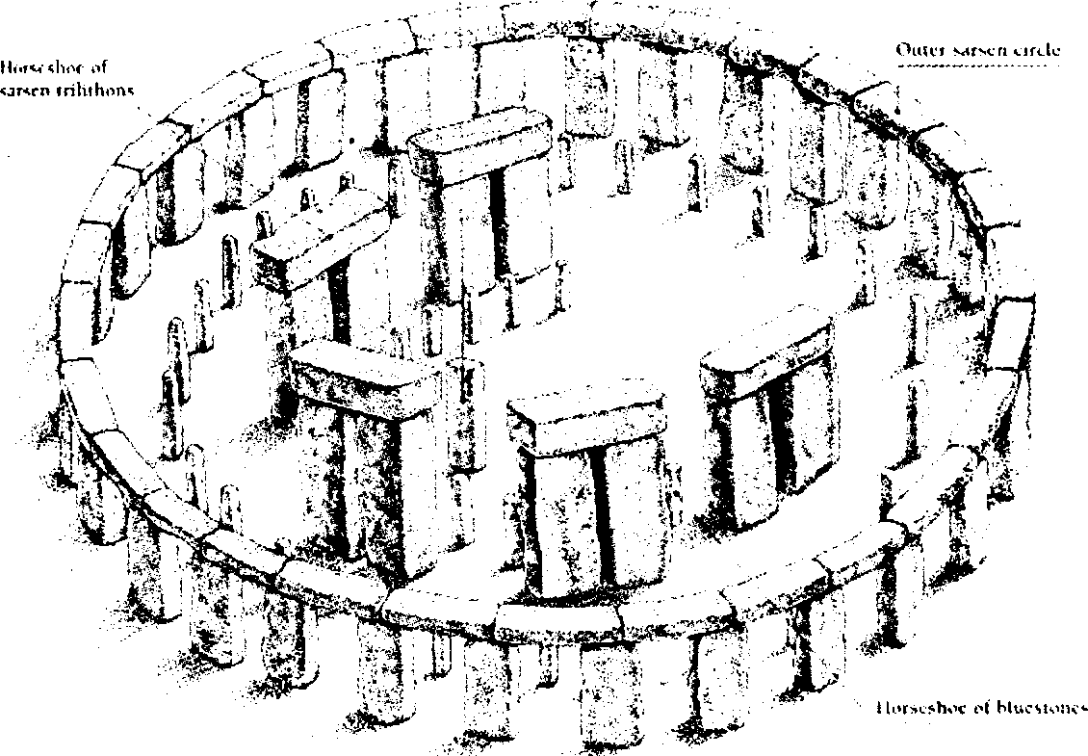
\h.\t Si.tnrOuter blucMotw

Azerbaijan Archaeology Vol.: 1 Num.: 1-2

bluestone from the Preseli Mountains in south-western Wales. With this they set up the double concentric circle of Menhirs (large, rough-hewn standing stones) within the earlier ring. Both the Avenue and the double circle were orientated toward the summer solstice sunrise. The double circle was never completed and was dismantled during the following period.
The 35-ton heel stone was possibly placed during the second period. Its
Marlborough Downs, 30 km (20 mi), the stones were shaped and jointed together with stone hammers. Other changes involved adding, moving, and rearranging stones that had been used during the second period. No other megalithic structure in north-western Europe displays the precision and architectural refinement that Stonehenge does. Some of the blue-stones were later reerected in the centre in an oval structure that contained at least two miniature trilithons, and holes


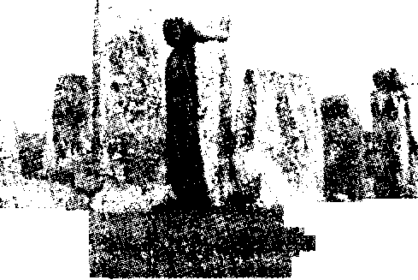
tlsfc
placement was one of the most sophisticated accomplishments of that age and provides the best evidence that early people used astronomy. On Midsummer Day (June 24 then, now June 21) a person standing in the centre of the circle can see the sun rise directly above the heel stone.


PERIOD III (c.2000 -1550 BC)

A circle of 30 sarsen-stone (weighing up to 50 tons each) uprights 30.5 m (100 ft) in diameter and capped by a continuous ring of sarsen lintels was erected in the centre of the site. This circle surrounds a horseshoe-shaped setting of five sarsen trilithons (formations in which two uprights support a lintel). After transporting the sarsen stones from were dug for the rest to be set in two concentric circles (the so-called Y and Z holes) outside the sarsen circle. This plan was abandoned unfinished, however, and the bluestones were finally rearranged (c.1550 BC) in the circle and horseshoe whose remains survive today.

PERIOD IV (c.1100 BC)

The Avenue was extended to the River Avon, 2 km (1.25 mi) from Stonehenge.
The earliest portion of the complex, which dates to approximately 3100-2300 BC, comprised a circular bank-and-ditch of about 330 feet (100 metres) in diameter. Just inside the earth bank is a circle of the 56 Aubrey holes (now invisible on the surface). Probably also

Two of the trilithons (added around 2100-2000 ВС). In front of them are two upright stones of the bluestone horseshoe (added around the same period)
Around 2000-1550 ВС, a horseshoe of smaller upright igneous stones without lintels (the bluestones) were brought from a site in Wales and placed inside the horseshoe of sarsens.
Finally, around 1550-1100 ВС, a circle of smaller upright bluestones was added between the outer sarsen circle and the outer horseshoe. Also added around this time are two concentric circle of holes - the so-called 'Y' and 'Z' holes.
Stonehenge is a monument that has been invented and reinvented over the centuries. It has been variously a Roman temple, a Druidic enclosure, the monument to King Arthur's family's exploits in war, the world's first computer. Stonehenge has been seen as exemplifying eternal truths in architecture, as a testbed for astronomical observation, and as a vehicle for space and time travel.
dating to this time are the four Station Stones (only two of which survive) and, on the north-east side, an earthwork which runs from the break in the bank-and-ditch. The now-fallen Slaughter Stone, located at the break in the bank-and-ditch, may date from this period, as may also the Heel Stone, located further out along the Avenue.
Part of the outer of sarsens (added around 2100-2000 ВС). In front of them are stones of the bluestone circle (added around 1550-1100 ВС)
Around 2100-2000 ВС, a circle about 108 feet (33 metres) in diameter comprised of originally of 30 neatly trimmed upright sandstone blocks (known today as sarsens), standing on average 13 feet (4 metres) above the ground, about 6.5 feet (2 metres) wide, and 3 feet (1 metre) thick, supporting a continuous ring of sarsen lintels (held in place by tongue-and-groove joints) was constructed in the centre of the original circular bank-and-ditch. A little later was added inside the circle of sarsens, in the shape of a horseshoe, ten upright sarsens arranged as five pairs with a single lintel. (Copyright- "Stonehenge", Collins and Brown Ltd, London (1997))
Ричард Пегг
Стоунһенч тарихи абидәси барәдә "Stonehenge", Collins and Brown Ltd, London (1997) адлы китабын әсасында јазылмыш гыса
мэ'луматын хүласәси.
Стоунһенҹ Инкилтәрәдә јерләшән өзүнәмәхсус мегалитик тарихи аби-дәдир. Ајры - ајры нәзәријјәләрә көрә Рум ибадәтханасы, друидләрин мү-гәддәс јери, инкилис Крал Артурун савашлар заманы көстәрдији гочаглыг вә икидликләринә һәср олунмуш јадикар абидәси, дүнјанын илк билкисајары кими јозулан Стоунһенҹ тарихи абидәсинин истифадә мәгсәди јүз илләр бојунҹа диггәт мәркәзиндә олмушдур. Стоунһенҹә аид олан башга тәфсирләрә истинад етсәк, о, ме'марлыгын әбәди дәјәрләрини әкс етдирмиш вә көјбилимсәл рәсәдхана кими истифадә олунмушдур.

