Azerbaijan Archeology Vol.: 2 Num.: 1-2
IŞĞAL OLUNMUS   

I
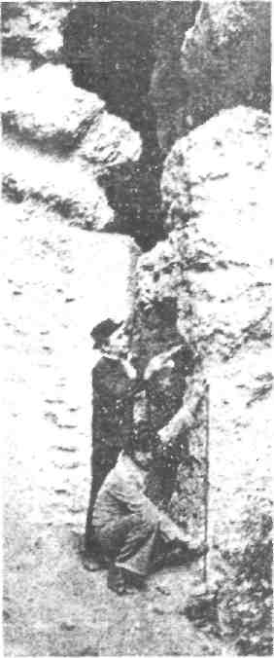
Azərbaycan Arxcologiyası 2000
Azerbaijan Archeology Vol.: 2 Num.: 1-2

Hunting was an extensive occupation of the inhabitants of Azikh Cave. Azikh man used to hunt 45 species of animals. The root of some of these animal species has been cut.
Cave bears and various species of deer were principle hunting objects for the Azikh people. The cave bear seemed to have religious significance for the Azikh man. A hiding place was discovered in the Acheulian layer near the hearths where skulls of the bears were laid out. All the skulls had been severed in a similar way. Both the upper and lower jaws were missing. In one case, two jawbones cut in halves
formed a cross. In another case, a cross was repeated graphically, and in another, a crossed notch was found among other notches on one of the skulls. No such phenomena had ever been for other relics of this period. The 4^{,h} stratum of the Azikh cave is sterile.
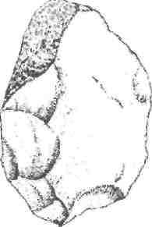
A rather strange phenomenon was discovered in the 4^{Ih} stratum (final Acheulian period). In this layer no evidence of human life was found. For some reason, it seems the inhabitants left the cave only to return to dwell there later on.
The question, of course, is why. This fact is evidenced
in other caves, as well. Could it have been that an upper
section of the cave had collapsed and people were afraid to
enter? Or had an accident occurred? Some archeologists suggests that after the Ice
Age the climate became warmer and people no longer needed to stay inside; as they
could live more openly in settlements.
According to prof. Mammadali Huseynov, in the beginning of mustye period azikhantrops again returned to the cave and till the mid of mustye period lived here.
More than two thousand stone artifacts and numerous animal bones were discovered in the 3^{r} stratum.
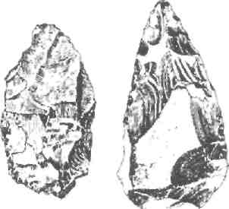
Azikh findings prove that, the territory of Azerbaijan was among the places of formation of primeval man on the Earth. Azikh is yet keeping the secrets about the earliest times of mankind.
One of Huseynov's greatest disappointment in life was that, since the late 1980s he was not able to continue his research in the Azikh cave because of the military threats and war in the region. Till his
last days he had not lost hope that the region would be liberated from armenian occupation. He died in 1994 at the age of 72, his dreams still not realized.

